

RE: Practical Nursing Program

Dear Interested Candidate,

Thank you for your interest in the Practical Nursing program. The program is a twelve (12) month, day program. Two (2) cohorts will be admitted each year (one in January and one in July). Attached is the *Recommended Course Sequence* which details the terms and courses. Admission to the Practical Nursing Program is highly competitive. We anticipate that the number of interested candidates will exceed the number of seats available.

The pre-screening process establishes eligibility for admission into the Practical Nursing Program. You must:   
• have an official high school transcript or GED diploma with scores.

• if you are a high school graduate from a foreign country or have an out-of-state GED, obtain a Certificate of Preliminary (CPE) Education from the Pennsylvania Department of Education.

• be at least 17 years old

• be a U. S. citizen, permanent resident, or eligible non-citizen.

Applicants who meet the following requirements are considered for admission (meeting the requirements is not a guarantee of admission into the program):

1. Meet the pre-screening requirements listed above.

2. Complete an application.

3. To qualify for admission into the Practical Nursing program, students must complete (5) credits of Anatomy and

Physiology (or the equivalent of Anatomy & Physiology I and Anatomy & Physiology II) and achieve a grade of C or higher, which can be completed at P.I.T. or transferred from a Middle States Accredited institution.

4. Complete AHT180 TEAS Smartprep course with a grade of C or higher or obtain a score of *PROFICIENT* or higher on the TEAS exam withing the last 2 years.

5. Submit official college or post-secondary education transcripts, if applicable.

6. Satisfactory background check, including a criminal record check and child abuse clearance for every state lived in within past 10 years. A FBI background check is required.

7. Completion of satisfactory drug screening.

8. Satisfactory physical examination including immunizations, titers, TdaP, and tuberculosis screening.

9. IF tuberculosis screening is positive, Chest X-ray with a doctor’s note within last 5 years is required.

10. CPR- Adult, Infant, child (AHA BLS Provider is recommended)

11. Flu vaccine

12. COVID-19 vaccine and recommended boosters

Enclosed are the *MINIMUM ADMISSION REQUIREMENTS DECLARATION* and *FREQUENTLY ASKED QUESTIONS* which provide further information about the Practical Nursing program.

If you do not meet the requirements, Pennsylvania Institute of Technology has other programs for people interested in a health care career. I encourage you to call (610) 892-1500 or (800) 422-0025 and ask to speak with an   
Enrollment/Admissions Specialist about these programs.

Best wishes to you as you begin the process of admission into the Practical Nursing program.

Sincerely,

Corey M. Dennis

Corey M. Dennis, MSNc, BA, BSN, RN, CNEn

Director, Practical Nursing Program

Enclosures

CMD/ Interest Letter Revised /04-2023



PENNSYLVANIA INSTITUTE OF TECHNOLOGY   
 PRACTICAL NURSING PROGRAM

MINIMUM ADMISSION REQUIREMENTS DECLARATION

|  |
| --- |
|  |
| Eligibility Requirement: |
| • Official high school transcript or GED with scores. * |
| • * Please note: GED from a state or jurisdiction other than PA requires a Certificate of Preliminary Education (CPE) from PA  DOE.  • Foreign high school also requires a Certificate of Preliminary Education (CPE) from PA DOE. |
| • At least 17 years of age - provide documentation |
| • U. S. citizen, permanent resident, or eligible non-citizen - provide documentation |
| Pre-requisite Requirements |
| • Must complete (5) credits of Anatomy and Physiology (or the equivalent of Anatomy & Physiology I and Anatomy &  Physiology II) and achieve a grade of C or better from a Middle States Accredited institution |
| • AHT180 TEAS Smartprep course C grade or higher OR a TEAS score of **PROFICIENT (58.7)** or higher within 2 years of start date |
| Admission requirements: |
| • Pennsylvania Institute of Technology College Enrollment Application |
| • Official high school transcript, GED transcript, or PA DOE CPE |
| • Official college transcripts, if applicable |
| • Completion of a PA Criminal background check within 12 months  ➢ Non-resident of Pennsylvania must also submit a Criminal Record check from the state in which he/she resides |
| • Completion of a PA Child Abuse background check within 12 months  ➢ Non-resident of Pennsylvania must also submit a Child Abuse Record check from the state in which he/she resides |
| • FBI Background Check is required within 12 months  ➢ Depending on results additional background checks maybe required |
| • Completion of satisfactory drug screening within 12 months; IF positive drug screening result, test may be redone one  time AFTER 60 days. |
| • Physical exam by health care provider within 12 months  ➢ Please note form MUST be signed and dated by provider |
| • Proof of immunization vaccination record OR Mumps, rubella, rubeola, and varicella titers showing immunity |
| • Booster vaccination(s) of mumps, rubella, rubeola, and/or varicella if titer non-reactive/non-immune with a repeat titer to  verify immunity |
| • Tetanus-diphtheria (TdaP) booster vaccination within the last 10 years |
| • Tuberculosis screening 1 step OR QuantiFERON blood test: negative results within 12 months  ➢ Please note: if positive results must provide Chest X-ray result done within last 5 years showing no active TB with an annual doctors note. |
| • Hepatitis B vaccination series of three (3) doses completed OR in progress |
| • Seasonal Flu vaccine is required |
| • COVID-19 vaccine is required per CDC guidelines to be considered “fully vaccinated” |
| • Current Certification in Adult, Infant and Child Healthcare Provider Cardiopulmonary Resuscitation (CPR) (American Heart  Association is recommended) However, if using another vendor, it MUST include all 3: adult, infant, child CPR and AED. |
| • Health insurance strongly recommended |
| • No outstanding fees owed to college |
| • Reliable transportation to clinical sites |

PLEASE NOTE:

While PIT and the Practical Nursing Program recognize certain exemption status, current clinical partners **do not accept medical or religious exemptions** currently. All background and health clearances must be obtained to attend clinical and satisfy the clinical requirement of the program.

There are no medical or religious exemptions accepted at this time.

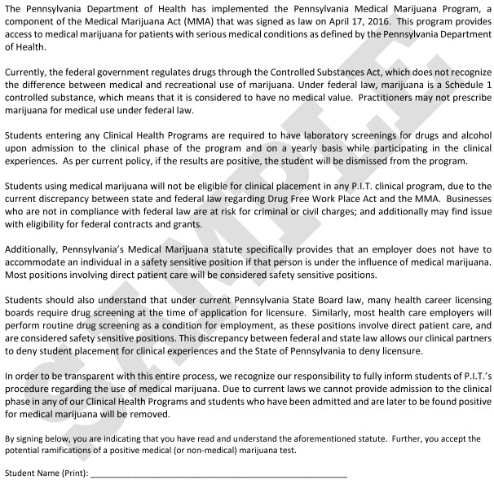

Pennsylvania Institute of Technology   
 Practical Nursing Program

FREQUENTLY ASKED QUESTIONS

1. What is the Practical Nursing (PN) Program?

The PN Program is a Certificate Program and is designed to prepare the student for a   
successful nursing career and employment in the healthcare field, to facilitate personal   
growth experience, and to provide Registered Nurse program transfer opportunities.

2. What are the requirements for admission into the PN Program and who is   
 responsible for paying for the cost, if any?

See attached MINIMUM ADMISSION REQUIREMENTS DECLARATION document.

3. Is the PN Program approved?

Yes. The program is approved by the Pennsylvania State Board of Nursing.

4. Will criminal history prevent acceptance into the program?

It depends on the specific details of the criminal history. One misdemeanor may not

prelude acceptance into the program while more than one and/or a felony conviction

usually does. To participate in clinical experiences a “no record” status must be reported on child abuse background checks, therefore, a history of child abuse precludes   
acceptance into the program.

If there is an “arrest” or “charge” listed on your criminal background check that does not have the “disposition” you will be required to provide official documents such as   
criminal background check from that state.

The Pennsylvania State Board of Nursing requires that the program inform applicants that the State Board of Nursing:

• may deny a license or the privilege of sitting for licensing examination to an   
 applicant who has been convicted* of a felonious act prohibited by the act of   
 April 14, 1972 (P.L.233, No.64) known as “The Controlled Substance, Drug,   
 Device and Cosmetic Act,” or convicted of a felony related to controlled   
 substance in a court of law of the United States or any other state, territory or   
 country unless:

• may refuse a license in any case where the board finds the applicant:

(1) Is guilty of gross immorality;

(2) Is unfit or incompetent by reason of negligence, habits or other causes;

(3) Has been convicted of a felony or a crime of moral turpitude, or been

dishonorably discharged or discharged under circumstances amounting to dishonorable discharge from the military;



2

(4) Is addicted to alcohol or is addicted to hallucinogenic or narcotic drugs or

other drugs which tend to impair judgment or coordination, or if he or she is judged to be mentally incompetent.

You will be asked these following questions upon acceptance and on the state licensure application:

(1) Have you ever been convicted* of any crime, felony or misdemeanor, and/or   
 do you currently have any criminal charges pending and unresolved, in any   
 court?

_____ Yes ____ No

(2) Have you ever been convicted* of any crime associated with alcohol or drugs   
 in any court?

_____ Yes ____ No

*The term “convicted” includes a judgment, found guilty by a judge or jury, pleaded

guilty or nolo contendere, received probation without verdict, disposition in lieu of trial or Accelerated Rehabilitative Disposition.

If the answer is yes to either one of the above questions you may have difficulty obtaining a license in Pennsylvania.

Deceit in the admission process is cause for dismissal from the program.

5. Are there any Pre-requisites?

Yes; to qualify for admission into the Practical Nursing program, students must complete   
and achieve a grade of C or higher for (5) credits of Anatomy and Physiology (or the   
equivalent of Anatomy & Physiology I and Anatomy & Physiology II), which can be   
completed at. P.I.T. or transferred from a Middle States Accredited Institution.   
Students must also complete AHT180 TEAS SmartPrep course with a C or higher which   
is completed at P.I.T or a score of **PROFICIENT (58.7)** or higher on the TEAS exam within two years of program entry.

6. How many credit hours is the program and how long will it take to complete the   
 program? Are the credits transferable to another school or college?

The curriculum is comprised of 50 nursing credits. The curriculum is divided into 4 terms of instruction for a total of 1500 hours. The full-time day program is a twelve (12) month program; the possibility of evening/weekend clinical rotations exists. Credits earned are not necessarily transferable to another school or college.

There are many opportunities for Licensed Practical Nurses to move up the educational ladder to obtain further specialty certifications or become a Registered Nurse. Both associate degree and bachelor’s degree programs are available. Many even offer credit for your practical nursing education.

3

7. What are the roles and responsibilities of a licensed practical nurse?

Nursing is an art and science dedicated to meeting the healthcare needs of individuals of all ages and communities. Licensed practical nurses (LPNs) provide healthcare in a   
variety of settings such as long-term care facilities, hospitals, physician’s offices, homes, rehabilitation facilities, and clinics. LPNs work under the supervision of a licensed   
professional (registered) nurse, a licensed physician, or a licensed dentist.

The nursing actions performed by LPNs are extensive. The list includes, but is not limited   
to, provide fundamental care, collect client information and data, perform routine   
monitoring, administer medications, enteral feedings, and intravenous therapy, and   
perform wound care, dressing changes, and respiratory treatments. LPNs provide health   
teaching, monitor effectiveness of treatments, and document data, actions and responses.   
LPNs are integral members of the healthcare team working together to assist the   
individual or family in the prevention of illness, restoration of health or adaptation to   
illness, and achievement of comfort.

8. Is there tutoring available?

P.I.T. is organized for student success. There are opportunities for peer, group, and   
private tutoring in our Student Resource Center, Student Innovation Center, Nursing   
instructors will be available for academic advising, tutoring, guidance, and support of   
nursing students.

9. What types of student services are available on campus?

Student Services provides academic support and career and transfer counseling as well as referral to social and community services. Other student services available include:   
cafeteria, student lounge, and student lockers. P. I. T. van service between P.I.T. and SEPTA’s 101 Trolley Station at Providence Road and State Road is available.

10. Will I receive a license immediately upon completion of the PN program?

No. Graduation from the PN program qualifies you to apply for a license and apply to take the NCLEX-PN® (National Council of Licensure Examination-Practical Nursing). You must apply to the State Board of Nursing and register for the examination. The State Board of Nursing determines if you are eligible to take the examination. When you pass NCLEX-  
PN® you will be issued a license.

11. What sites are used for clinical learning experience? Is transportation provided   
 to and from the clinical sites?

Clinical environments are: hospitals, nursing homes, assisted living, acute care facilities, community centers, pediatric facilities, correctional facilities, and elementary schools. Clinical also occurs on campus in the Simulation lab and may also occur online with a Virtual client and assignments. Negotiations for additional clinical environments for clinical learning experiences are ongoing. The possibility of evening/weekend clinical rotations exists. Clinical sites are not limited to Delaware County, and maybe out of state. Students are responsible for their own transportation. Clinical site placement is decided by nursing faculty. Requests for clinical site placement with peers or at specific agency will not be honored.

12. What type of patient/patients do student nurses care for during clinical learning   
 experiences?

The Pennsylvania State Board of Nursing requires that clinical learning experiences

provide opportunities for students to care for men, women, and children in a variety of age groups. Therefore, each student will be assigned to (and expected to) care for men, women, and children with a variety of health problems. Students are not permitted to refuse a patient care assignment.

13. What resources are available to help fund my nursing education?

Financial aid is available for those students who qualify, through federal, state,

institutional, and special programs. Student loans are available. Some employers offer   
tuition forgiveness (repay outstanding loans for education) programs in exchange for   
employment. There are also professional and community organizations that offer   
scholarships to nursing students. For further information on federal, state or college aid   
go to [www.fasfa.gov.](http://www.fasfa.gov./) P. I. T. Student Financial Aid Office is available to assist students   
in applying for financial aid.

14. Are there computer requirements for the nursing program?

Yes. All exams that are given online are recorded and monitored live via a Webcam. In addition, virtual patients can only be accessed through a laptop or desktop. iPads and smart phones can be used for lecture but are not compatible with other products,   
learning platforms, and software.

15. **Is my acceptance into the program guaranteed?**

Acceptance into the Practical nursing program is a highly competitive process with

limited seating available. All perspective students must ensure that they have all minimum

admission requirements met by the deadline prior to beginning the program.



Hepatitis B Declination Form

I understand that I may be at risk of acquiring Hepatitis B Virus

infection during my clinical experiences, as a result of working with blood or other potentially infectious body fluids. I have read the   
attached statement about Hepatitis B and the Recombivax vaccine and understand the benefits and risks of Hepatitis B vaccination.

However, I decline Hepatitis B vaccination at this time. I understand   
that by declining this vaccine, I continue to be at risk of acquiring   
Hepatitis B, a serious disease. I also understand that placement in a clinical facility may be denied. If in the future I continue to have   
occupational exposure to blood or other potentially infectious body   
fluids and I want to be vaccinated with Hepatitis B vaccine, I may do   
so.

Signature________________________________________ Date____________________________________________



PENNSYLVANIA INSTITUTE OF TECHNOLOGY   
 PRACTICAL NURSING PROGRAM

ADMISSION REQUIREMENTS DECLARATION

* + - I understand all submitted documents and completed forms become the property of the College   
       and are nonreturnable.
    - I understand deceit in the application procedure is cause for dismissal from the program.
    - I understand I must provide official high school transcript, GED transcript, or PA Department of   
       Education (DOE) Certificate of Preliminary Education (CPE).
    - I understand a student will not be admitted in the program with a disqualifying criminal history or   
       child abuse clearance.
    - I understand a student must have reliable transportation to clinical sites and that lack of transportation can contribute to program dismissal.
    - I understand a student will not be admitted with a disqualifying result in the drug screening.
    - I understand a student accepted into the program must submit a health examination form completed by a healthcare provider with immunization history which can include verification through blood work. I understand a student will not be admitted with a disqualifying result.
    - I understand in circumstances of student illness, injury, or other health limitations, if the clinical agency does not accept me it may result in my not being accepted into the program or will result in failure of the course.
    - I understand that I should give careful consideration to the mental and physical demands of the program prior to beginning the program.
    - I understand that I must provide proof of documentation of a COVID vaccination, or I cannot   
       attend clinical which will result in failure of the course.
    - I understand that I must provide proof of documentation of a seasonal flu vaccine, or I cannot   
       attend clinical which will result in failure of the course.
    - I understand I must provide documentation of current Adult, Child, and Infant CPR (Healthcare   
       Provider) certification.
    - I have read and understand the Clinical Health Program Medical Marijuana Procedure at   
       Pennsylvania Institute of Technology.
    - I understand the Practical Nursing program is a 1500 clock hour, 12-month, day program.
    - I understand failure to provide documents or failure to meet deadlines is ground for rescinding of admission or dismissal from the program.
    - **I understand that the Practical Nursing program at Pennsylvania Institute of Technology has a limited number of spaces and admission to the program is a competitive process.**
    - **I understand that there are no medical, religious or exemptions of any kind granted.**
    - I, the undersigned:

• Have read and understand the Practical Nursing Program Admission   
 Requirements.

• I understand that I am responsible for doing or obtaining and paying for the cost   
 of requirements designated to the candidate.

• I understand that meeting the requirements is not a guarantee of admission into   
 the program.

• I understand that the program has a limited number of spaces and admission is not guaranteed.

_________________________________________________________ __________________

Signature of candidate Date

Pennsylvania Institute of Technology   
 Practical Nursing Program

Health and Immunization Record

Name (PRINT) _____________________________________________ Date of Birth ____________________

|  |  |
| --- | --- |
| Part A. Must have titers (within last 5 years) for the following OR  an immunization record showing vaccinations: | If titer result is non-immune/non-reactive, need to receive a  vaccine AND FOLLOW UP RESULTS. Document below  administration of vaccine AND FOLLOW UP RESULTS |
| • Rubeola immunization ⁭ (attach a copy of record)  Rubeola titer results (attach a copy of titer results)  Results ⁭ immune ⁭ non-immune/non-reactive | Date of rubeola vaccine, if necessary:  Results ⁭ immune ⁭ non-immune/non-reactive Date: |
| • Rubella immunization ⁭ (attach a copy of record)  Rubella titer results (attach a copy of titer results)  Results ⁭ immune ⁭ non-immune/non-reactive | Date of rubella vaccine, if necessary:  Results ⁭ immune ⁭ non-immune/non-reactive Date: |
| • Varicella immunization ⁭ (attach a copy of record)  Varicella titer results (attach a copy of titer results)  Results ⁭ immune ⁭ non-immune/non-reactive | Date of varicella vaccine, if necessary:  Results ⁭ immune ⁭ non-immune/non-reactive Date: |
| • Mump immunization ⁭ (attach a copy of record)  Mump titer results (attach a copy of titer results)  Results ⁭ immune ⁭ non-immune/non-reactive | Date of mump vaccine, if necessary:  Results ⁭ immune ⁭ non-immune/non-reactive Date: |
| Part B. Vaccinations  Tetanus/Diphtheria vaccine within the last 10 years?  If yes, date : If no, needs booster, date administered : | |
| Hepatitis B vaccine* (must begin vaccination series prior to start of program)  Dates received First dose _____________________ Administered by ______________________________  Second dose ___________________ Administered by ______________________________  Third dose ____________________ Administered by ______________________________  *If had the series but doesn’t have documentation, needs Hepatitis B titer Results ⁭ immune ⁭ non-immune/non-reactive  Attach a copy of result and if non-immune/non-reactive, date of Hepatitis B vaccine booster  **Please note: If declining Hepatitis B vaccine series please sign and upload Hepatitis B waiver | |
| Part C. Tuberculosis screening -  Tuberculin skin test (Mantoux), 1-step PPD administered within 12 months:  1. Administered on __________________ Date read ___________________ Results ⁭ negative ⁭ positive  OR if not a candidate for tuberculin skin test provide date of QuantiFERON administered within 12 months:  QuantiFERON Date_______ Results ⁭ negative ⁭ positive (if positive must have chest x-ray) Attach a copy of result WITH a PCP note  Chest x-ray Date__________ Results ⁭ normal ⁭ abnormal Attach a copy of chest x-ray report WITH a PCP note | |
| Part D. Results of physical exam. Health Care Provider please check one of the following statements. Thank you.  _____ There were no findings or health conditions indicative of limitations in physical activity, or cognitive function or ability to perform the  functions required of a student in a Practical Nursing program.  _____ There are findings or health conditions* that require special accommodations or may indicate limitations in physical activities, cognitive function, and/or ability to perform the functions required of a student in a Practical Nursing Program. *Attach a list of those findings or health*  *conditions*.  PRINT Name of Health Care Provider ______________________________________________Phone number _______________________  SIGNATURE of Health Care Provider _________________________________________________________________________________  DATE:____________________________ | |

Instructions for this form:

*UPLOAD THE COMPLETED, SIGNED, AND DATED FORM TO YOUR CLEARANCES ACCOUNT

* UPLOAD THE COMPLETED, SIGNED AND DATED HEPATITIS B WAIVER FORM TO YOUR CLEARANCES ACCOUNT IF APPLICABLE.

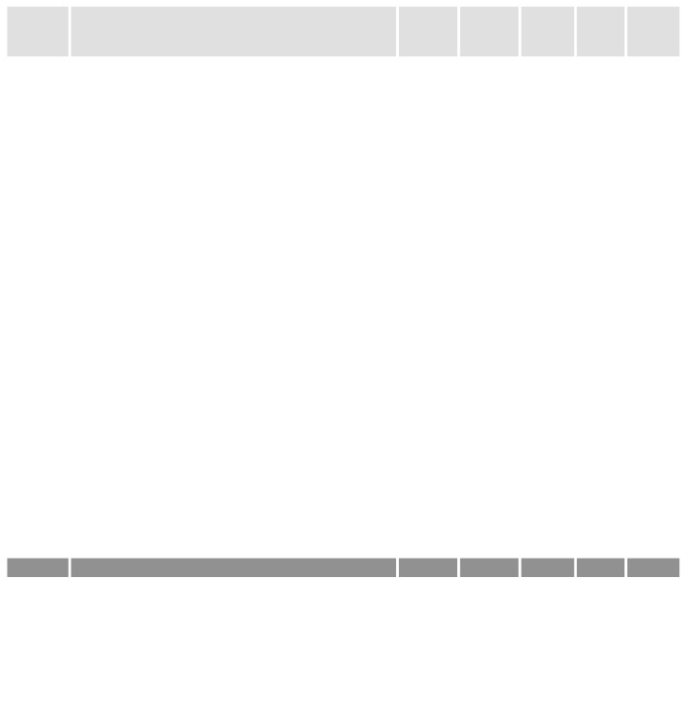

PENNSYLVANIA INSTITUTE OF TECHNOLOGY   
 PRACTICAL NURSING PROGRAM

Plan of Study*

|  |  |  |  |  |  |  |  |
| --- | --- | --- | --- | --- | --- | --- | --- |
| Course  Code | Course Title | Lecture  Hours/  Week | Lab |  | Clinical  Hours/  Week | Credits | Total  Hours |
| Hours/  Week | |
| Pre-Req: | A&P and AHT180 or equivalent |  |  | |  |  |  |
| TERM 1 |  |  |  | |  |  |  |
| NUR 140 | Nursing Fundamentals | 6.81 | 10.9 | | 10.9 | 11 | 315 |
| NUR 145 | Role Development of the Practical Nurse | 1.36 | 0 | | 0 | 1 | 15 |
|  | Semester totals | 90 | 120 | | 120 | 12 | 330 |
| TERM 2 |  |  |  | |  |  |  |
| NUR 152 | Nursing Care of Adults | 8.18 | 0 | | 21.8 | 10 | 330 |
| NUR 155 | Principles of Pharmacology | 1.36 | 2.72 | | 0 | 2 | 45 |
|  | Semester totals | 105 | 30 | | 240 | 12 | 375 |
| TERM 3 |  |  |  | |  |  |  |
| NUR 162 | Intravenous Therapy | 1.36 | 1.36 | | 0 | 1.5 | 30 |
| NUR 165 | Nursing Practice Specialties | 4.09 | 4.09 | | 21.8 | 8.5 | 330 |
| NUR 167 | Clinical Concepts of Pharmacology | 1.36 | 2.72 | | 0 | 2 | 45 |
|  | Semester totals | 75 | 90 | | 240 | 12 | 405 |
| TERM 4 |  |  |  | |  |  |  |
| NUR 170 | Acute and Complex care of Adults | 9.54 | 0 | | 21.8 | 11 | 345 |
| NUR 175 | Practical Nursing Capstone | 4.09 | 0 | | 0 | 3 | 45 |
|  | Semester totals | 150 | 0 | | 240 | 14 | 390 |
|  |  |  |  | |  |  |  |
|  | Total Program Months = 12 |  |  | |  |  |  |
|  | Total Program Weeks= 44 |  |  | |  |  |  |
|  | Classroom Hours: 8:00am- 4:00pm |  |  | |  |  |  |
|  | Clinical Hours: 6:45 am-2:45 or 8:00 am–4:00 pm * times vary per site |  |  | |  |  |  |
|  | Program Totals | Total  Lecture | Total  Lab | | Total  Clinical | Total  Credits | Total  Hours |
|  |  | 420 | 240 | | 840 | 50 | 1500 |

****This page left intentionally blank

R&R CMD 4/20/2023